Revision Date: | 01NOV14 | State of Illinois Emergency Management Agency | Hazard ID: | BAKKEN CRUDE OIL
Revised By: |  | Hazardous Materials - CHEM | Use By: | TBD (Not accepted for use)

SHORT-TERM RESPONSE OBJECTIVES |  | RESOURCE GUIDELINE FOR RESPONSE
- Provide on-site representation (LNO)  - Establish Situational Awareness  - Establish a Disaster Intelligence Section  - Establish privates sector liaison/vBEOC  - Establish Public Information/Warning section  - Provide Public Information Messaging  - Assist in evacuation  - Assist in temporary sheltering  - Assist/Establish traffic and access control  - Law enforcement  - Traffic signs  - Traffic barricades  - Provide for responder health and safety  - Provide environmental oversight and monitoring  - Provide communications  - Establish UAC  - Provide containment capability  - Trucks, HVY and light equipment  - Sand  - Ad/Absorbent material/resources  - MABAS (State) activated resources  - Provide decontamination resources  - Assist in medical T-T-T (Injured)  - Assist in fatality management  SECONDARY CONSIDERATIONS  - Responder/public monitoring/evaluations  - Environmental impact - Remediation  - Long-term monitoring and sampling  - Loss of economy and infrastructure  - Personnel Protective Equipment  - Psychological implications  - Secondary hazardous materials releases  - Secure access and area security |  | RESOURCE TYPE | QNTY | PURPOSE
 |  | IEMA Regional Coordinator  IEPA SIRC LNO  ICC SIRC LNO  ISP SIRC LNO  IDPH SIRC LNO  IDNR SIRC LNO  ARC SIRC LNO  IDA SIRC LNO  IDOT – H SIRC LNO  IDOT – A SIRC LNO  Sworn Officers – L/E  IEPA Hazardous Materials Response Team  ITEC Team and Trailer  Communications Vehicle  End Loader  Trucks  Back Hoe/Digger  Skid Steer  Chainsaws  Sweeper  Message Boards  Arrow Boards  HWY Labor (Personnel)  Day Labor, General (Personnel)  Mobile Command  Regional Command Trailers  Logistics Trailer  Cars, Passenger  Personnel – UAC – FWD AO  Personnel – UAC – FWD AO  EMAT – IESMA  IMT – IESMA  Decontamination Vehicle (MABAS)  IEMA Public Information Officer (PIO)  Business Emergency Operations Center  Sand/Gravel  Ad/Absorbent Materials |  | LNO to IC and/or CEOC  C3 Agency Response  C3 Agency Response  C3 Agency Response  C3 Agency Response  C3 Agency Response  C3 Agency Response  C3 Agency Response  C3 Agency Response  C3 Agency Response  Force Security and Protection / T/A  Environmental Oversight/Intelligence  Communications (Interoperability)  Communications (Interoperability)  Debris Removal and Management  Debris Removal and Management  Debris Removal and Management  Debris Removal and Management  Debris Removal and Management  Debris Removal and Management  Debris Removal and Management  Traffic and Access control  Traffic and Access control  Debris Removal and Management  Logistics Support  C3/Interoperable Communications  Resource Management / Logistics / FWD AO  Transport / Damage Assessment / Mobility  Liaison / Staffing UAC  Recovery Specialists / DA  Emergency Management – Plans, Coord. & Mgmt.  Incident Command – Coordination  Decontamination Services  Public Information/Warning and Coordination  BEOC – vBEOC  Containment/confinement  Containment/confinement, environ re-mediation

SAFETY CONSIDERATIONS AND WARNINGS
- Staff will maintain a safe working environment throughout operations.
- Due to the extended working period, staff will be cognizant of stress, fatigue, and the need for adequate rest periods.
- All staff should be cognizant of potential lift, trip, fall, pinch, electrical, puncture, chemical and environmental hazards associated with operations.
- Any and all situations warranting law enforcement intervention will be immediately directed to the appropriate authorities. At no time will staff intercede in law enforcement activities.
- Injuries or medical concerns/conditions will be reported to the medical staff on-site immediately and/or 911 as appropriate.
PHYSICAL AND CHEMICAL PROPERTIES | COMMON RAIL CONVEYANCE
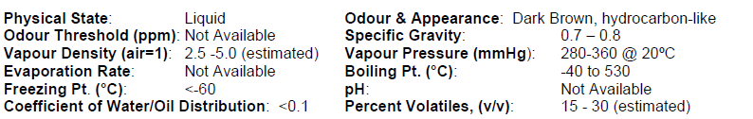 | 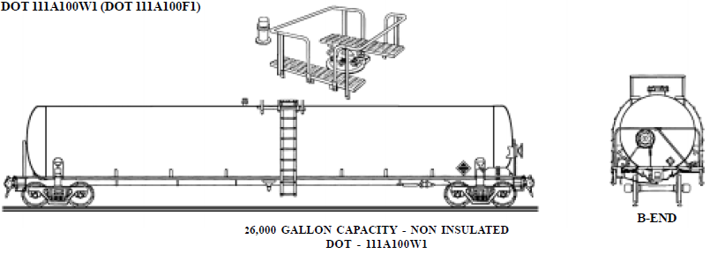
STABILITY AND REACTIVITY
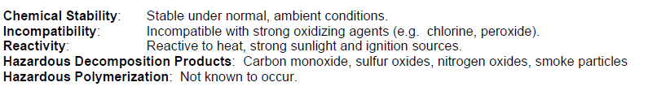 | CHEMTREC 1 – 800-424-9300  NRC 1 – 800-424-8802
TOXICOLOGY INFORMATION | ERG/PHMSA
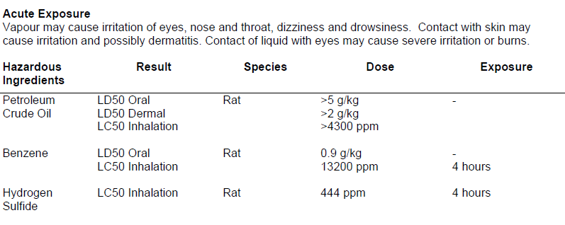 | 2012 - Emergency Response Guide – 128  - Highly flammable  - Inhalation and contact hazard  - Isolate spill or leak 150’ in all directions  - Protective Clothing – SCBA  - Eliminate ignition sources  - Evacuation  - Large Spill – 1,000’ downwind  - Fire  - Tank, Rail Car, Tank Truck  - Isolate for ½ mile all directions

